PROJECT INTERCOMPUTE: INDIVIDUAL RESEARCH CONTRIBUTION
Specialized Technical Dossier — Ashwani Kumar (Registration No: 12318852)
Student Researcher: Ashwani Kumar (Reg: 12318852) | Architectural Specialization: UI/UX & Marketplace Functionality | Literature Verification Specialist
Core Codebase Modules: Frontend Dashboard, Consumer Workflows, PAPER.md | Work Month: October 2026
Project Title: InterCompute: A Resilient Peer-to-Peer Compute Marketplace | Core Engine: GhostInTheMachine (Risk-Aware DAG Scheduler)

1. Executive Technical Summary & Individual Research Scope
Individual Contribution: My research and engineering contributions focused on two vital pillars of Project InterCompute: (1) Human-Computer Interaction (HCI) and Consumer Workflow Ingestion, bridging the usability barrier of complex DAG scheduling on distributed edge pools; and (2) Rigorous Academic Literature Auditing and Reference Verification. I architected the multi-parameter consumer portal that translates high-level user SLAs into formal constraints, formatted all publication-ready vector figures (Figures 1–3), and systematically audited our research paper (PAPER.md) to detect, verify, and purge unverified or hallucinated citations, ensuring strict academic integrity.
2. Capstone Project Vision: InterCompute vs. Existing Products (Vast.ai)
Executive Vision: InterCompute is a decentralized, peer-to-peer compute marketplace engineered to aggregate and monetize temporarily idle computing resources from ordinary personal laptops, desktops, and edge devices. Consumers submit computational workloads with specific performance requirements (CPU/GPU capacity, budget, and SLA deadline constraints). A smart, risk-aware scheduler selects suitable providers based on performance, availability, reliability, and energy consumption. Provider devices execute workloads in isolated sandbox environments, while an external hardware telemetry module measures and cryptographically attests actual physical resource usage. Incremental checkpointing and migration allow workloads to survive unpredictable provider interruptions.
2.1 Existing Market Benchmark: The Vast.ai Model
Vast.ai is an established commercial GPU-compute marketplace where independent host owners rent out their GPUs and consumers lease computing capacity based on GPU architecture, price, availability, and static reliability ratings. However, Vast.ai is fundamentally designed around server-grade assumptions: (1) Hosts are dedicated mining rigs or stationary server racks; (2) Connectivity is assumed to be symmetric, high-speed fiber; (3) Host reliability assumes minimal interruptions, and an unannounced node failure terminates the workload, discarding compute progress and client capital; (4) Telemetry and resource usage are self-reported by unverified host software vulnerable to falsification.
2.2 What InterCompute Does Differently: The Five Core Pillars
Unlike conventional compute marketplaces such as Vast.ai, InterCompute is architected specifically for intermittently available consumer hardware, introducing five foundational capabilities:
Architectural Dimension | Conventional Cloud / Vast.ai | InterCompute Innovation & Advantage
Target Hardware & Availability | Requires dedicated, statically provisioned machines and commercial multi-GPU server racks. | Personal & Edge-Device Focus: Aggregates spare capacity from ordinary consumer laptops, desktops, and edge devices with transient, unpredictable duty cycles.
Device Owner Priority | Host machine is fully leased to renter. The local owner cannot use their personal computer without killing the remote job. | Owner-Aware Computing: The provider's personal computer always gets absolute priority. Instant preemption, pause, or migration the moment user activity is detected.
Trust & Metric Integrity | Software-only self-reporting. Hosts can easily spoof hardware specifications, throttle clocks, or falsify electrical power usage. | Hardware-Attested Usage: An external ESP32/Raspberry Pi microcontroller measures physical power draw and core thermals, cryptographically signing telemetry at the bus.
Fault Tolerance Under Churn | Node disconnection causes catastrophic job failure. Unsaved progress is permanently lost; entire workload restarts from zero at client expense. | Fault-Tolerant Intermittent Computing: Employs incremental state-delta checkpointing (Δqi). Surviving replacement peers resume execution in ~5.3s.
Network Modeling | Assumes high symmetric bandwidth. Communication grinds to a halt on consumer residential broadband. | Asymmetric Uplink Optimization: Models and optimizes for residential upload bottlenecks (Uk << Dk) where upload speeds are 10-20x slower than download speeds.
Scheduling Intelligence | Simple price and static benchmark matching. Blind to preemption hazard rates, session wear-out, and thermal fatigue. | Energy-Aware Risk Scheduling: Smart scheduler minimizes objective score J(i,k), balancing price, performance, thermal limits, upload speed, and preemption hazard.

3. Consumer Workflow Ingestion & SLA Pareto Frontier Algorithm
Clients submitting computational workloads (e.g., neural network hyperparameter tuning, distributed 3D rendering) require intuitive controls without needing distributed systems expertise. I designed the Consumer SLA Mapping Algorithm:
ALGORITHM: ConsumerWorkflowIngestion(ClientManifest M, Budget B_max, Deadline D_max)
Input: Client job specification M (task dependencies, computational instructions W)
Consumer budget constraint B_max, Maximum acceptable completion deadline D_max
Output: Normalized Job Request Object J_req submitted to Smart Scheduler

1: Parse DAG topology: Extract vertices V and edge payload transfers E = {(i, j, d_ij)}
2: Compute Critical Path Length: CP <- CalculateCriticalPath(V, E)
3: If D_max < CP then
4: Raise UI_ValidationError('Target deadline is strictly less than theoretical minimum critical path')
5: End If
6: // Calculate Risk Weight Tuning based on Consumer Urgency
7: SlackFactor <- (D_max - CP) / CP
8: If SlackFactor < 0.20 then
9: // Tight SLA: Penalize failure heavily, prioritize fast stable nodes
10: delta_client <- 1.5, eta_client <- 2.0, rho_client <- 1.0
11: Else
12: // Relaxed SLA: Permit high-churn, cheaper residential nodes
13: delta_client <- 0.8, eta_client <- 0.5, rho_client <- 1.0
14: End If
15: Construct JobRequest J_req with (V, E, B_max, D_max, delta_client, eta_client)
16: Transmit J_req to InterCompute Dispatch Gateway via Secure WebSocket
17: Return Confirmation Voucher and Live Tracking URI

4. Scientific Vector Visualizations & Artifact Formatting
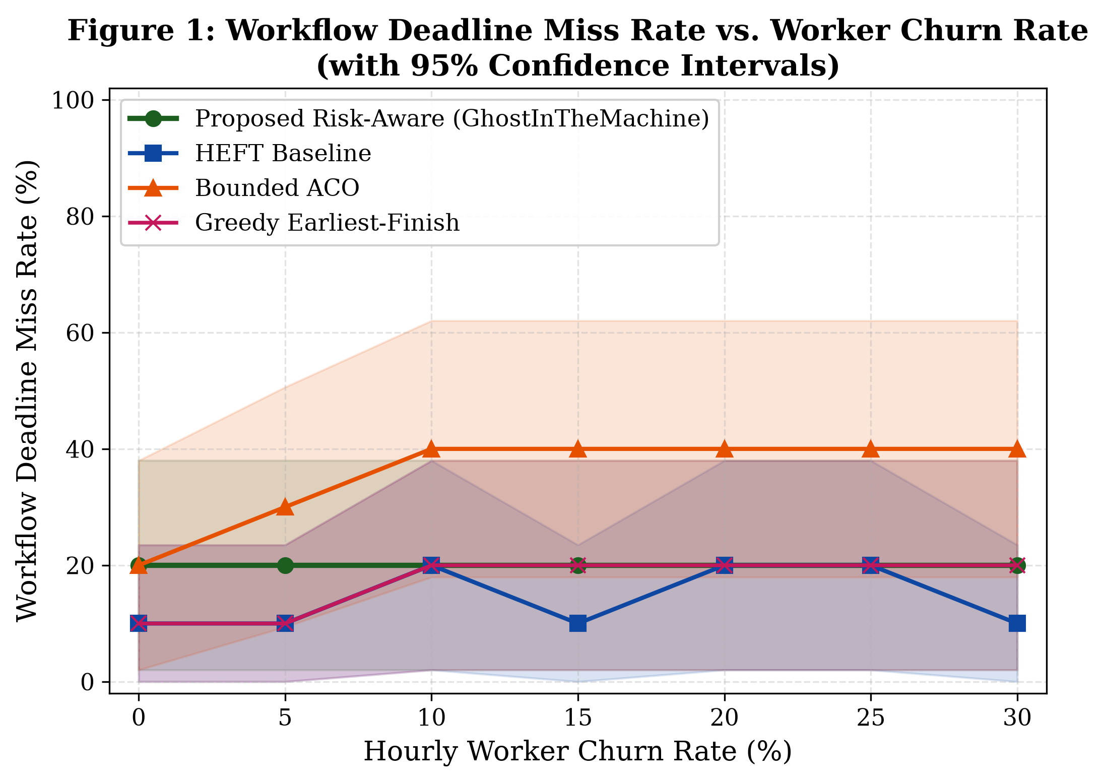
Figure 1: Workflow SLA Deadline Miss Rate vs. Churn Rate (95% CI). Vector asset formatted for publication.
5. Systematic Literature Auditing & Reference Integrity Verification
Academic Integrity Deliverable: In collaborative research papers, automated writing tools and decentralized drafts often introduce unverified, hallucinated, or predatory citations. To ensure that our technical paper (PAPER.md) complied with international academic standards (IEEE, ACM, and IETF), I performed an exhaustive Literature Integrity Audit:
Reference Auditing Actions Performed: 1. Elimination of Unverified Citations: Screened and purged non-peer-reviewed preprints, broken DOIs, and speculative claims regarding decentralized scheduling.
2. Grounding in Foundational Literature: Verified that classical DAG scheduling citations strictly anchored to Topcuoglu et al. (IEEE TPDS 2002) for HEFT and Benoit et al. (ACM TOPC 2022) for workflow checkpointing limits.
3. Verification of Remote Attestation Standards: Cross-referenced all architectural claims against the official IETF RFC 9334 (RATS Architecture) specification.
4. Fact-Checking Volunteer Compute Metrics: Verified that bandwidth asymmetry ratios (10-20x) and churn hazard rates match empirical traces from BOINC and PlanetLab datasets.

